LAB DOC – Security Shepherd

1. [Insecure Direct Object References](javascript:;)

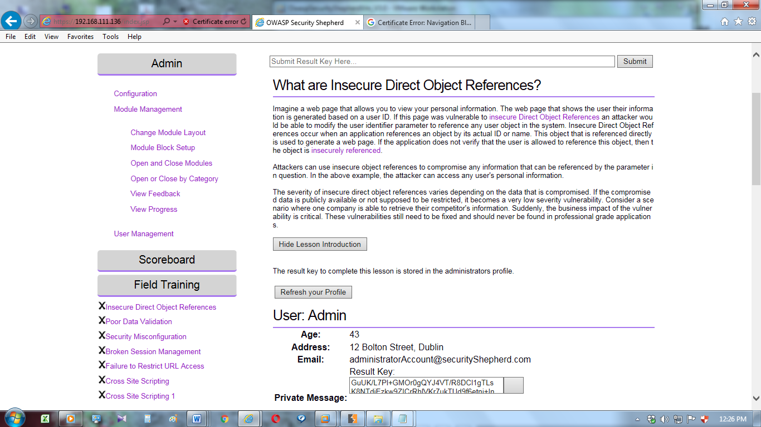

Solution - Change the user name to : admin

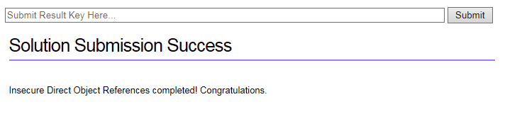

1. [Poor Data Validation](javascript:;)

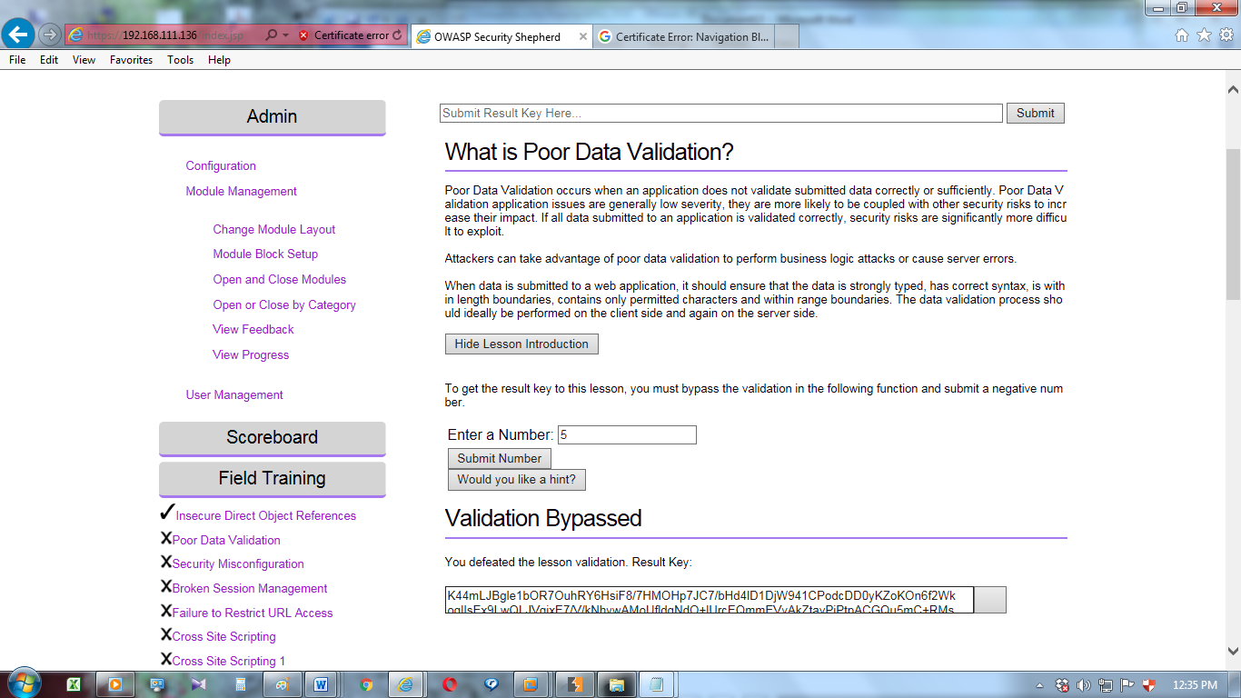

Solution - Change the userdata=-5

1. [Security Misconfiguration](javascript:;)

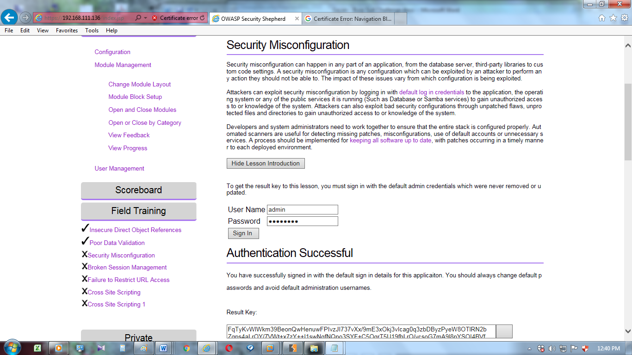

Solution - Use default Username : Admin

Password : password

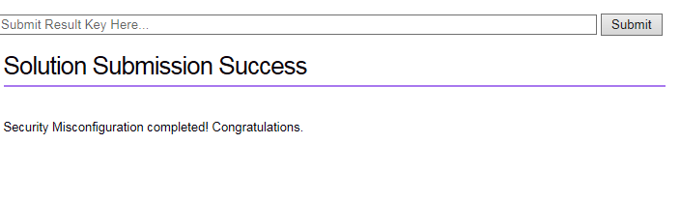

1. [Broken Session Management](javascript:;)

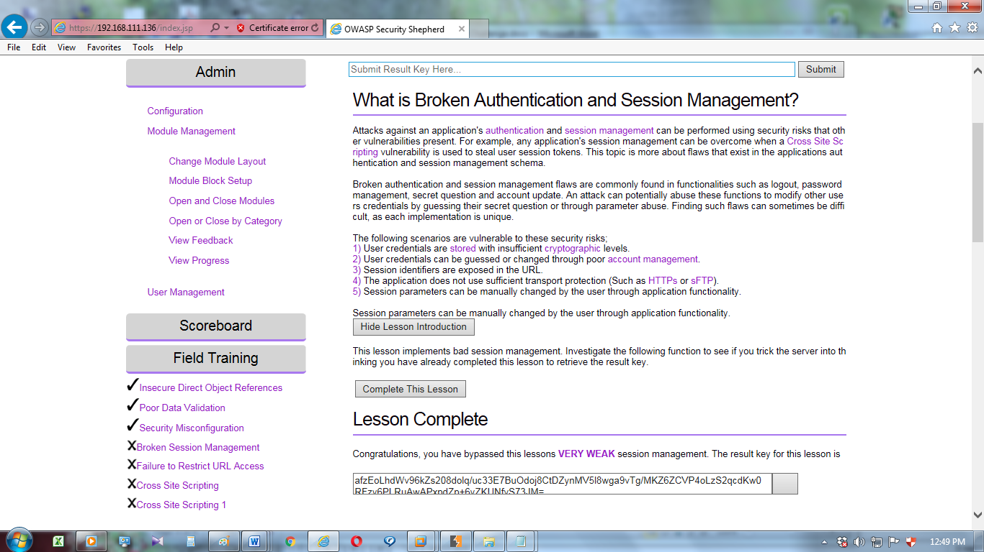

lessonComplete=lessonComplete

Solution - change lessonComplete=lessonNotComplete

to lessonComplete=lessonComplete

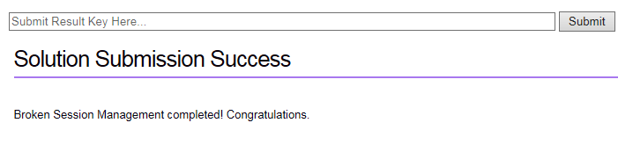

1. [Failure to Restrict URL Access](javascript:;)

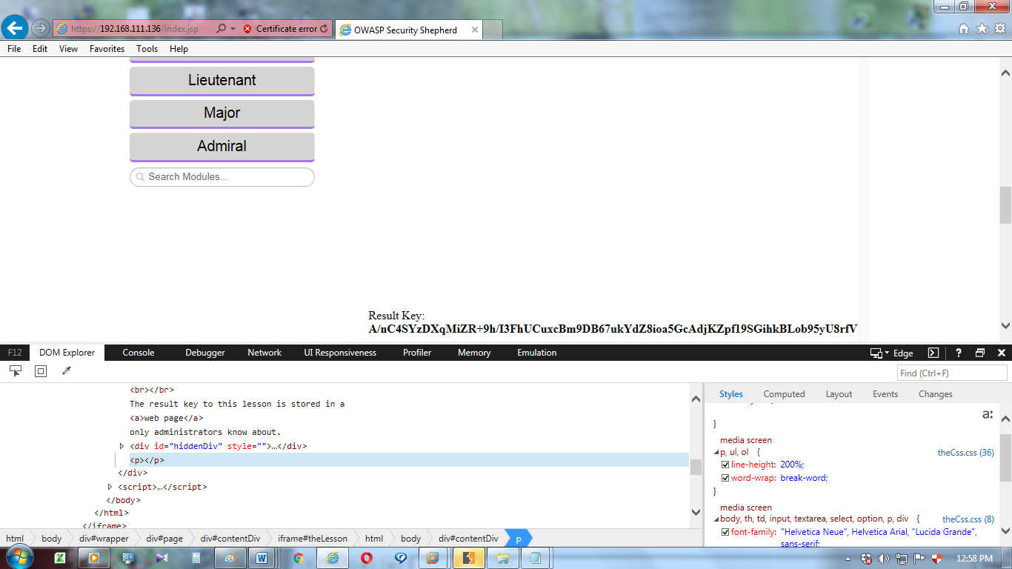

Solution – Change <div id="hiddenDiv" style="display: none;">

to <div id="hiddenDiv" style="display ;">

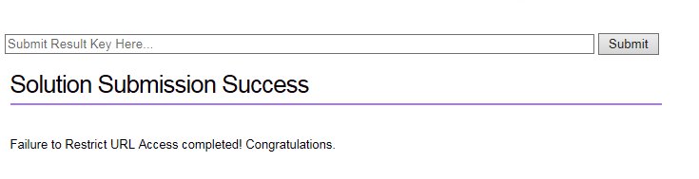

1. [Cross Site Scripting](javascript:;)

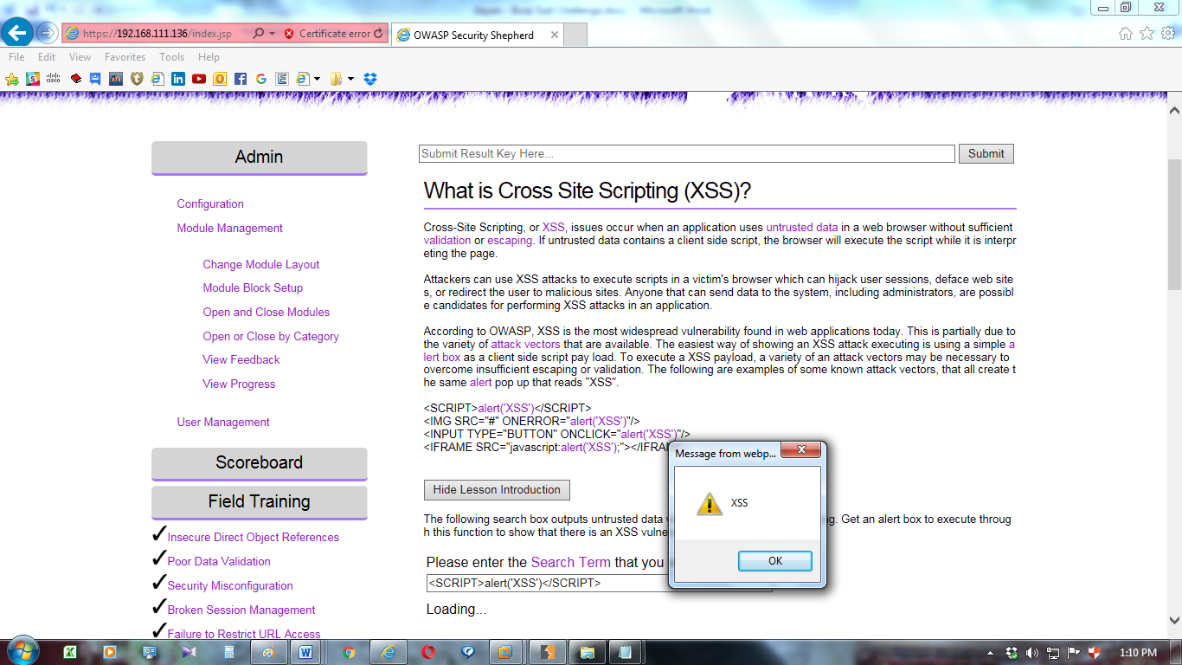

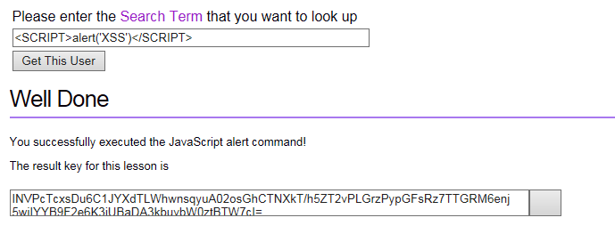

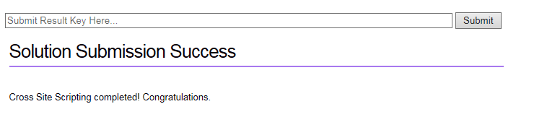

1. [Cross Site Scripting](javascript:;) 1

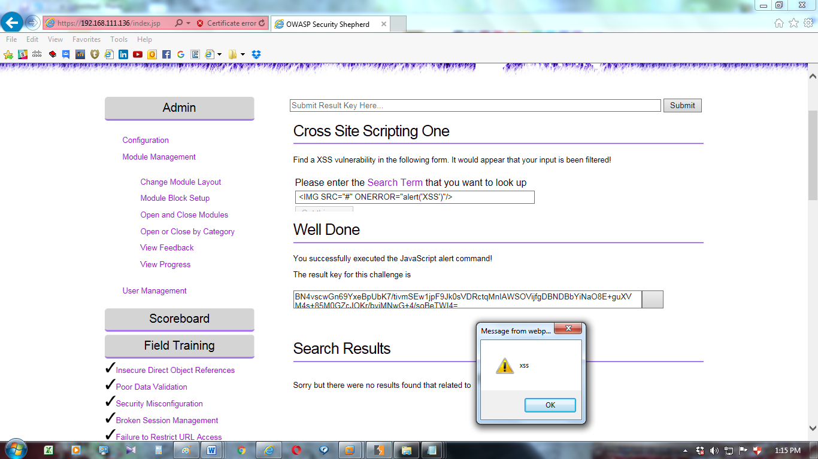

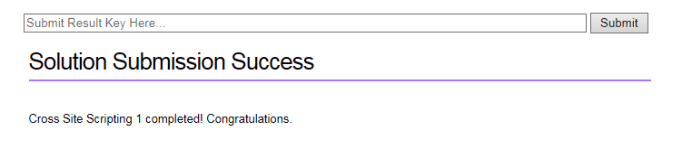

PRIVATE

[Insecure Cryptographic Storage](javascript:;)

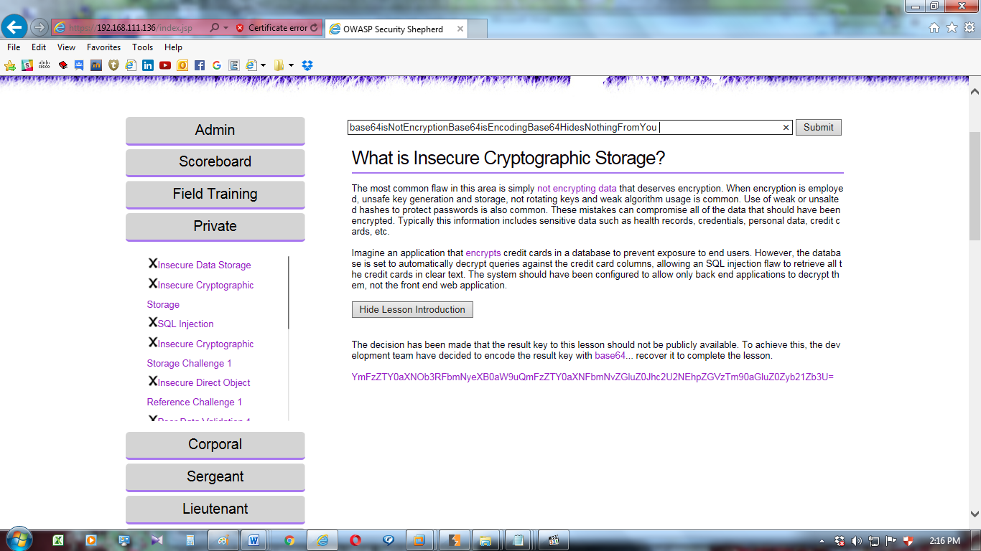

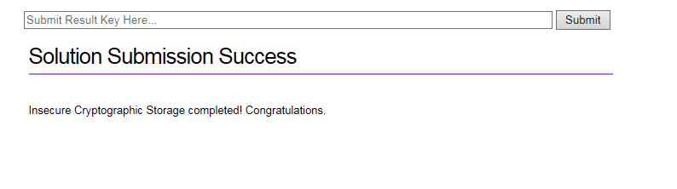

[SQL Injection](javascript:;)

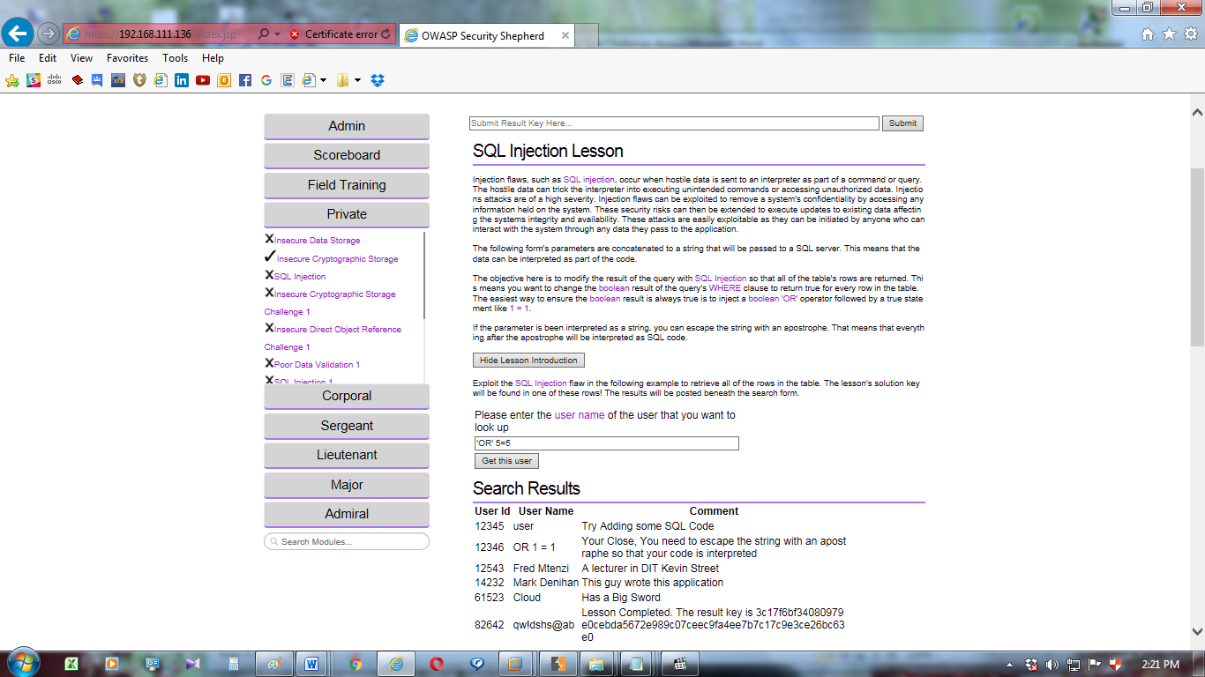



[Insecure Cryptographic Storage Challenge 1](javascript:;)

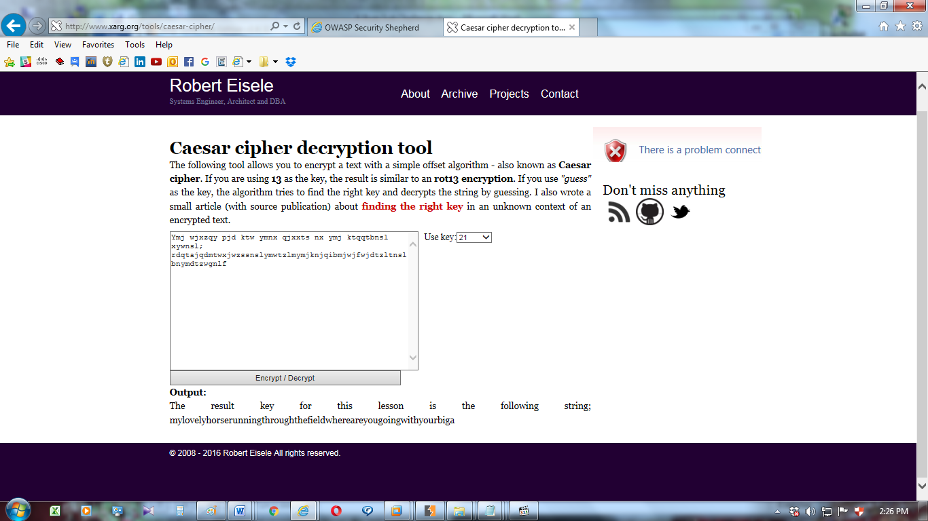

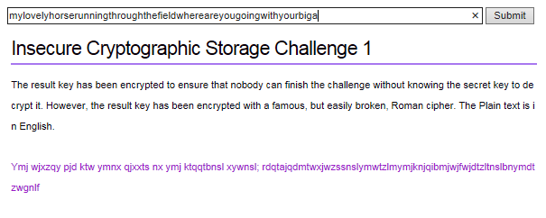

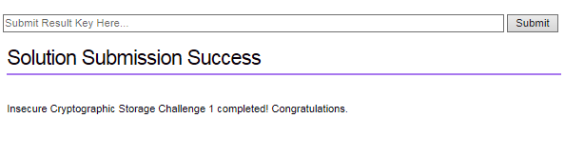

[Insecure Direct Object Reference Challenge 1](javascript:;)

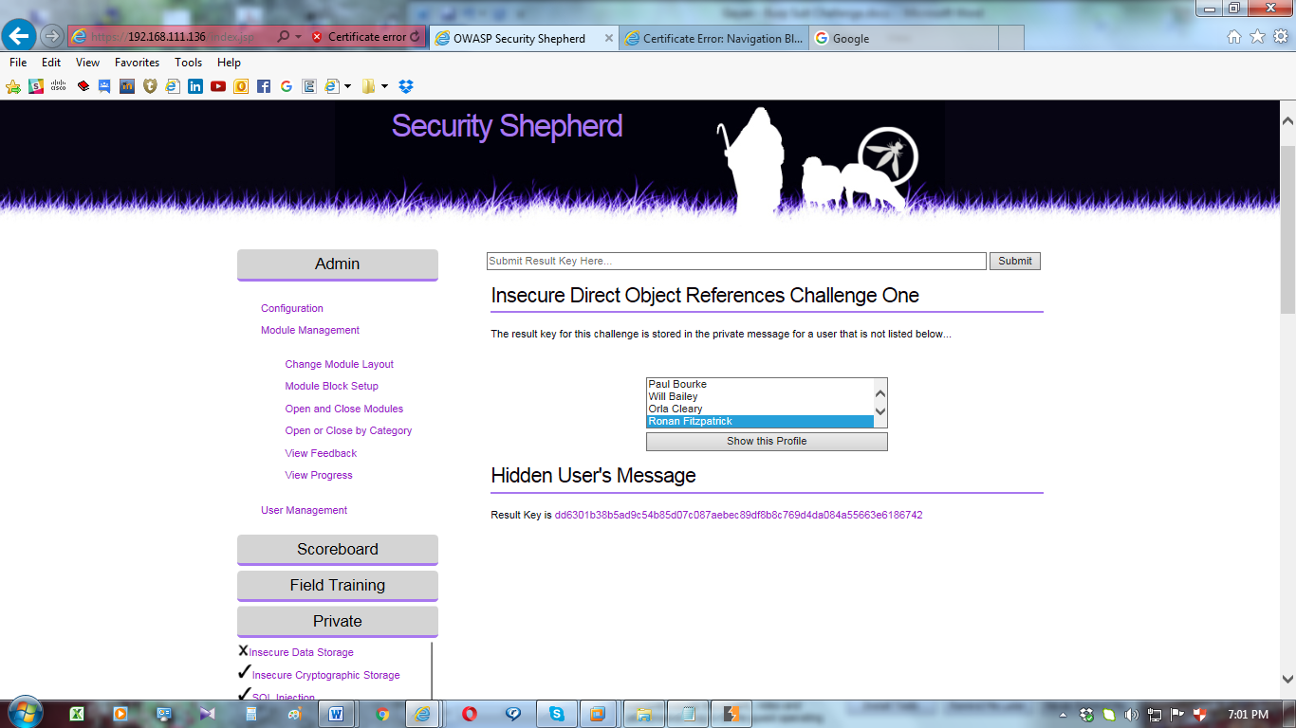

Solution: change userId%5B%5D=7

To userId%5B%5D=11

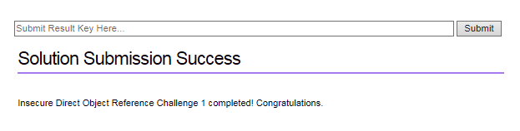

[Poor Data Validation 1](javascript:;)

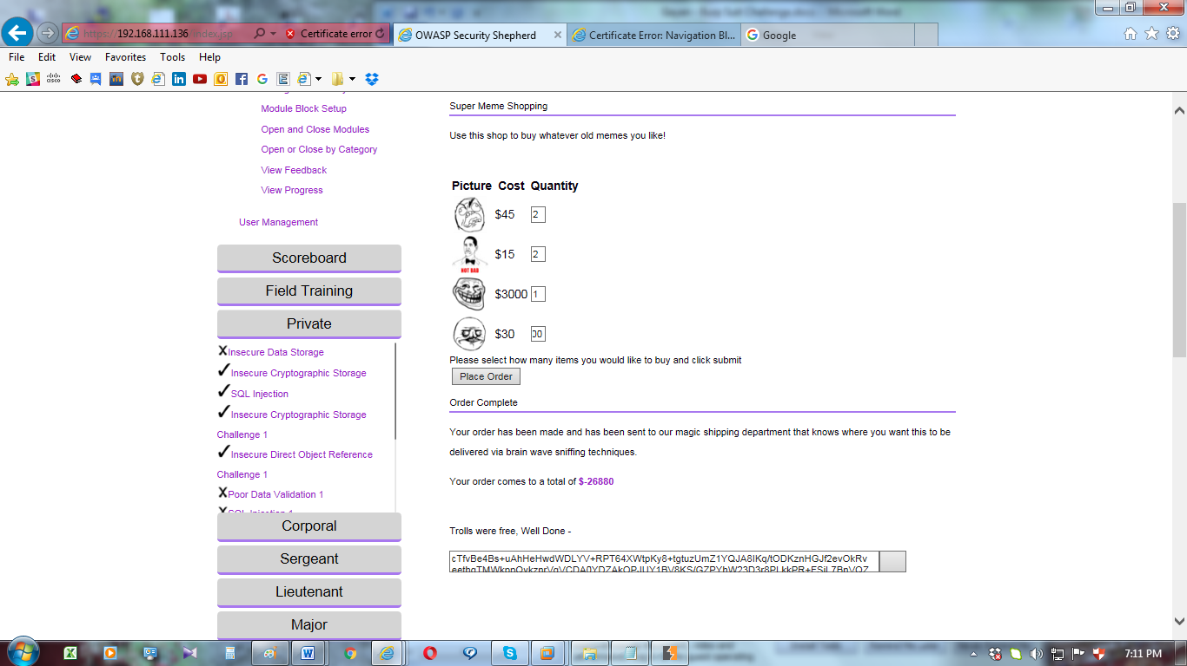

Solution : Enter quantity value as -1000 in $30

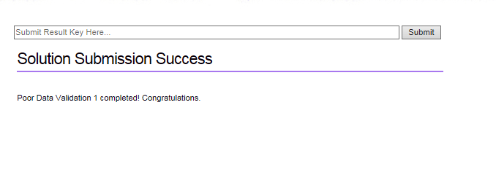

[SQL Injection 1](javascript:;)

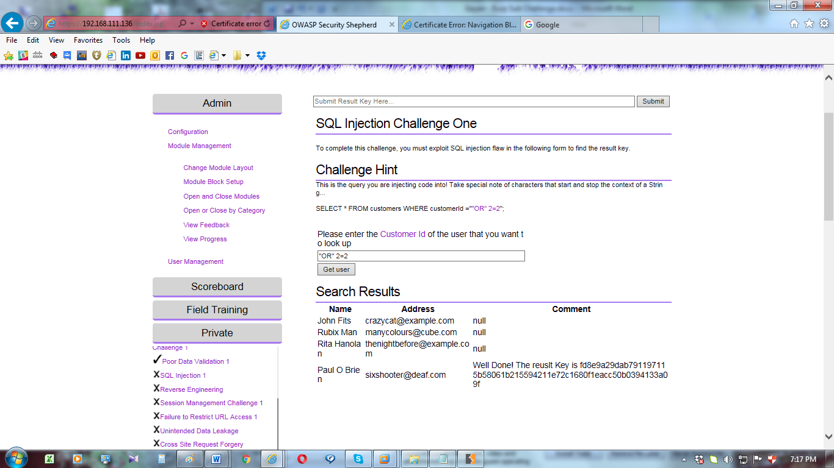

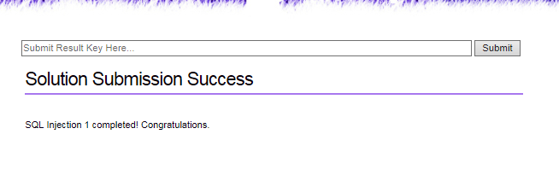

[Session Management Challenge 1](javascript:;)

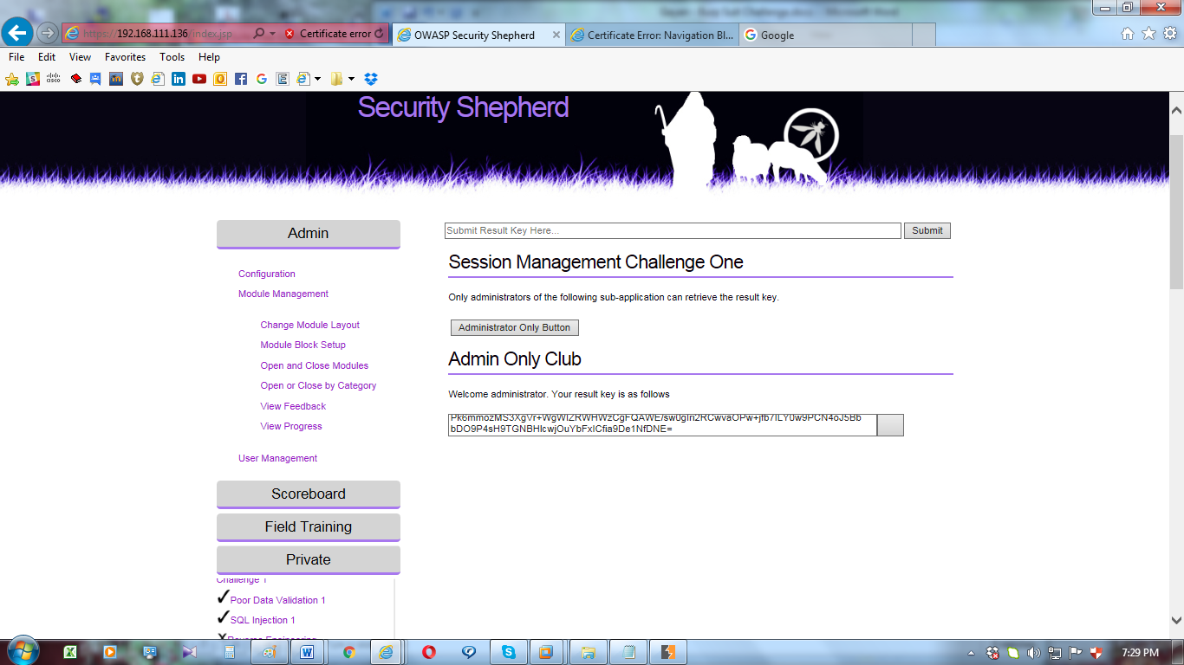

Checksum value dXNlclJvbGU9dXNlcg== (Decode/base64) 🡪 userRole=user

userRole=administrator ( Encode/bas64) dXNlclJvbGU9YWRtaW5pc3RyYXRvcg==

change the checksum=dXNlclJvbGU9dXNlcg= to ;

checksum= dXNlclJvbG9YWRtaW5pc3RyYXRvcg===

